🚀 Project: CI/CD Pipeline on AWS (Node.js App + AWS + Jenkins Developed by SIVA PRASAD SINGU)
This project demonstrates a complete CI/CD pipeline built using modern DevOps tools to automate deployment of a Node.js application.
From code commit to production deployment — everything is automated.

🔁 CI/CD Workflow
- Developer pushes code to GitHub
- GitHub webhook triggers Jenkins
- Jenkins pipeline executes:
  - Checkout source code
  - Install dependencies using npm
  - Start application using PM2
- Application is deployed on Amazon Web Services EC2 instance
- App becomes live and accessible via public IP

⚙️ Tech Stack
- ☁️ AWS EC2 (Ubuntu Server)
- 🔁 Jenkins (Master + Agent)
- 🔗 GitHub Webhooks
- 🟢 Node.js
- 📦 npm
- ⚡ PM2 (Process Manager)
- 🐧 Ubuntu Linux
## 🚀 AWS EC2 Infrastructure Setup

This screenshot shows the AWS EC2 instances used for the CI/CD pipeline.

- Jenkins Master instance (t2.medium)
- Jenkins Agent instance (t3.micro)
- Both instances are in running state
- Instances are configured for distributed builds (Master-Agent architecture)

💡 The Master handles pipeline orchestration, while the Agent executes build jobs.
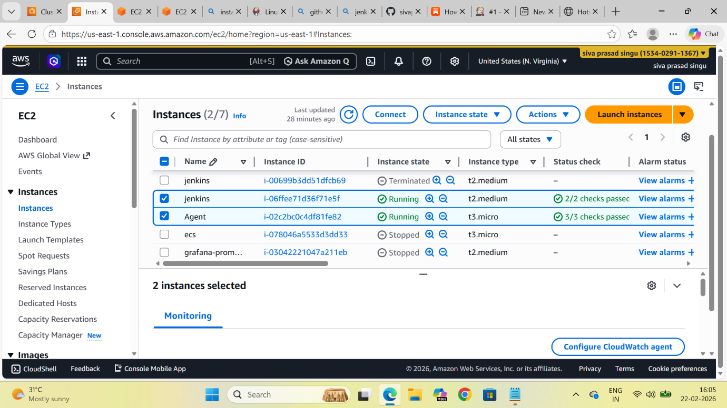
Application Running with PM2
This screenshot shows the application running on the EC2 instance using PM2.
- PM2 process manager is used to run the Node.js application
- Ensures high availability and automatic restarts
- Application is running in production mode
- Displays process status, uptime, CPU, and memory usage
💡 PM2 keeps the app alive, manages multiple instances, and handles crashes automatically.
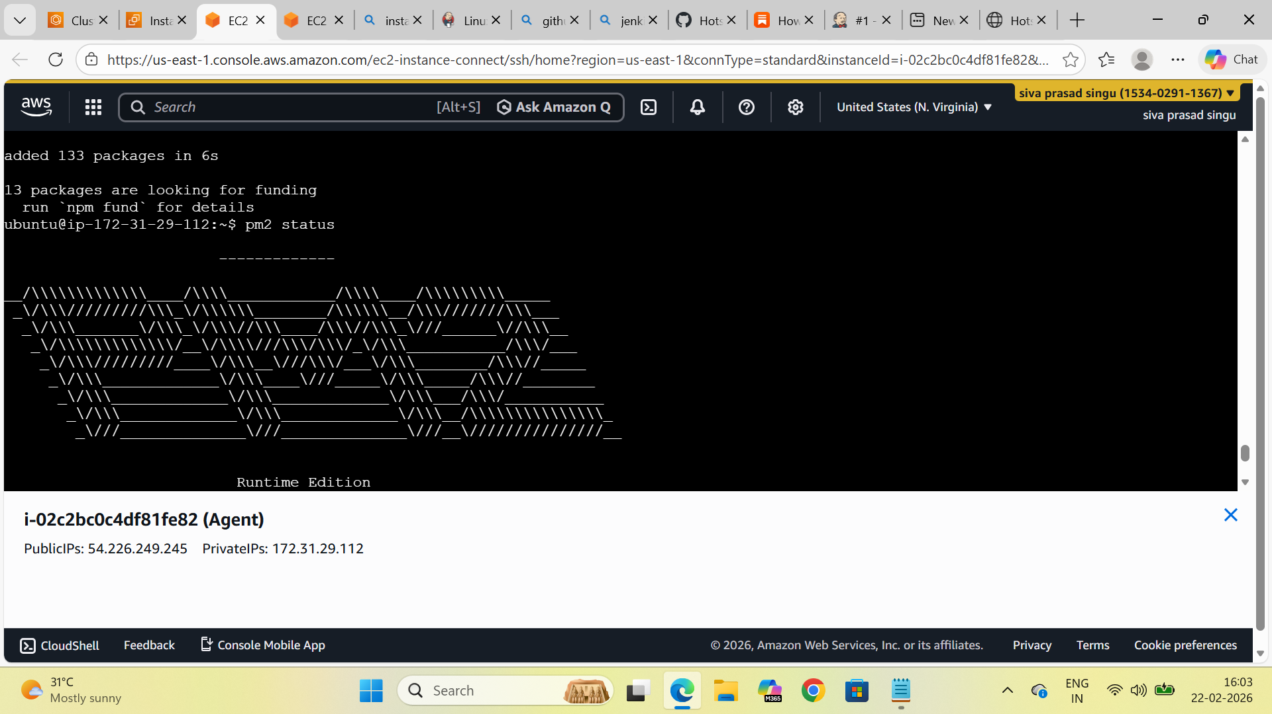

🖧 Jenkins Distributed Build Architecture
This screenshot displays the Jenkins nodes configured for distributed builds.
- One Built-in Node (Master)
- One Agent Node (AGENT1)
- Both nodes are connected and in sync
- Shows system metrics like disk space and response time
💡 The Master manages pipeline execution, while the Agent handles build tasks, improving scalability and performance.
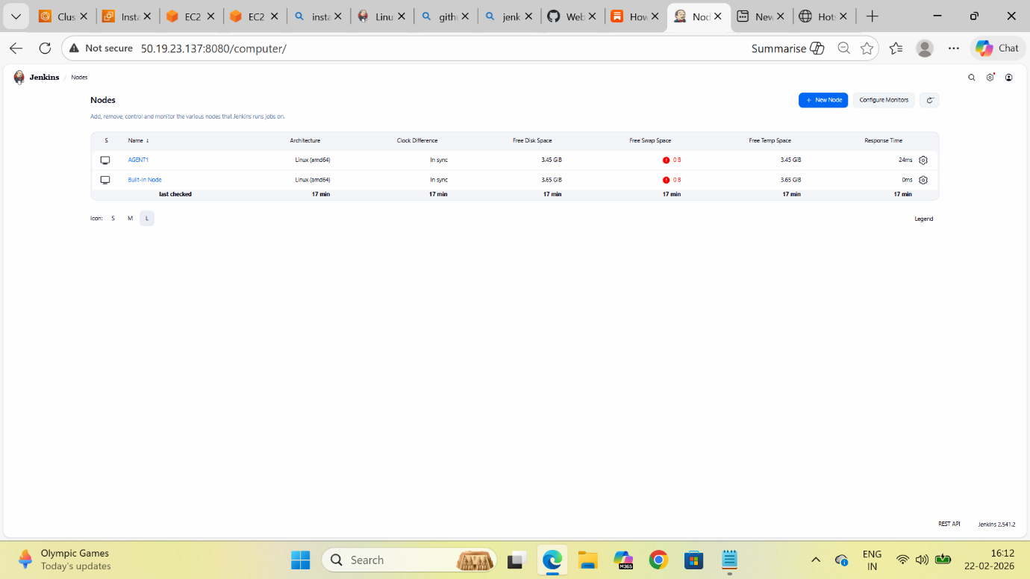

⚙️ Application Running on EC2 via PM2
This screenshot shows the application running on an EC2 instance through the terminal.
- PM2 daemon started successfully
- Application (hotstar1) running in fork mode
- Status: online
- Displays CPU and memory usage
- Confirms successful deployment on server

💡 This verifies that the application is properly deployed and running in the production environment.
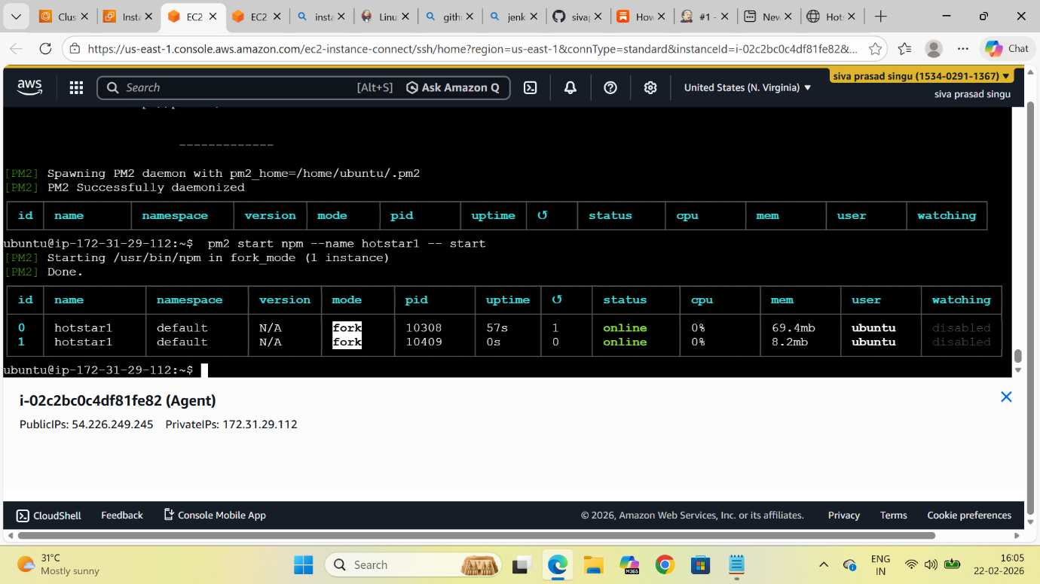
🔁 Jenkins Pipeline Triggered by GitHub Webhook
This screenshot shows the Jenkins pipeline execution triggered automatically after a GitHub push.
- Build triggered by GitHub webhook
- Pipeline started within seconds
- Fully automated CI/CD workflow
💡 No manual intervention required — push to GitHub triggers the pipeline.
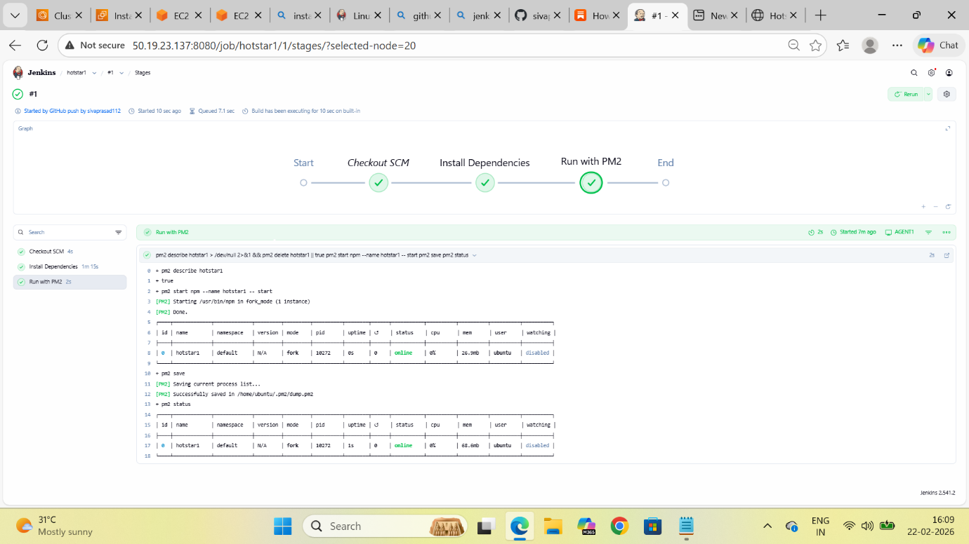

🌐 Live Application Deployment
This screenshot shows the deployed Node.js application running in a web browser.
- Application is hosted on AWS EC2 instance
- Accessible via public IP and port (e.g., :3000)
- UI resembles Disney+ Hotstar interface
- Successfully serving content to users
💡 This confirms the CI/CD pipeline is working end-to-end — from code push to live production deployment.


